LOCATION
3595 Las Vegas Blvd. S.
Las Vegas, NV 89109
Phone Number: 1-844-I-AM-CROM (1-844-4-26-2766)
Website: www.TheCromwell.com
Digital Media Center: http://caesars.thedigitalcenter.com/
Twitter: http://twitter.com/cromwellvegas
Facebook: http://facebook.com/cromwellvegas
Google+: https://plus.google.com/u/0/b/100966723410612581644/

Part of the Caesars Entertainment portfolio of resorts, The Cromwell earned the distinguished Forbes Recommended Award in 2016. The distinction signifies that The Cromwell is among the best hotels in the world. The only true standalone boutique hotel on the famous Las Vegas Strip, the hotel features 188 well-appointed rooms including 19 distinctive suites; GIADA, the first-ever restaurant by celebrity chef and television personality Giada De Laurentiis; Drai’s Beach Club • Nightclub, a 65,000-square-foot venue offering panoramic partying on The Cromwell’s rooftop by nightlife impresario, Victor Drai; and Bound by Salvatore, an elevated hotel lobby bar experience helmed by world-renowned bartender Salvatore Calabrese.

- 40,000-square-foot casino with 66 table games, 434 slot machines and a reserved gaming salon
- The hotel bar and lounge, Interlude, with its centralized location and close proximity to nightlife serves as a social-inspired gathering place featuring cutting edge mixology
- Bound by Salvatore brings a new meaning to the lobby bar experience. Salvatore’s more than 30 years of experience shines with perfectly executed cocktails, never-before-seen espresso cocktails, elegant champagne cocktails and signature creations.
- Multiple vantage points showcase great views of the Las Vegas Strip
- Restaurant by Giada De Laurentiis

HOTEL DESIGN

The Cromwell blends vintage with modern, with black Parisian-style awnings and gold fixtures adorning the windows. From the moment guests enter the Porte-Cochère, a boutique hotel experience that blends traditional elements with Parisian flare and whimsical, modern details, awaits.

The hotel reception is reminiscent of a parlor from the past; accessories and bookshelves adorned with leather-bound books clad the walls.

HOTEL ROOMS

- The 169 standard accommodations evoke a residential feel with distressed hardwood flooring, vintage luggage and trunk-style furnishings Lighting recalls French provincial styling
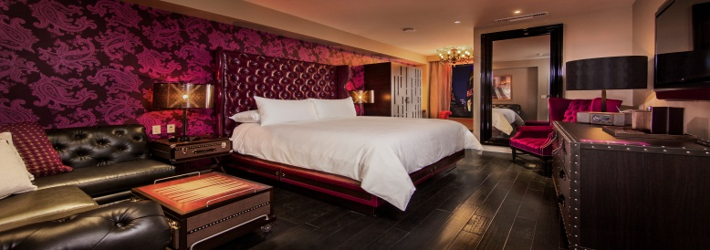
- Black and white mosaic tiled shower walls act as the canvas for playful English-French phrases
- All rooms offers a make-up vanity area with showgirl lighting
- Full length mirror and plush seating
- 55-inch Television
- Standalone wood closet
- Muk products

E-KEY TECHNOLOGY
Caesars Entertainment continues to be on the forefront of the hospitality industry by creating the most immersive and innovative resort experience in the world.The Cromwell was the first hotel on the Strip to use eKey, allowing guests the option of using an electronic key in lieu of a traditional hotel key to access their room. The program allows the guest’s experience to begin earlier, often before they even steps foot into the hotel. This allows guests to choose when, where and how they check-in or out of our hotels creating a level of personalization seldom found among the world’s largest hotels.

GIADA
Located on the second story of The Cromwell, above the most exciting and dynamic intersection in the world, GIADA accommodates nearly 300 guests and encompasses three dining experiences – a dining room, a lounge and a terrace. GIADA also has three private dining rooms that can be used together or separately. Now open for lunch, GIADA’s menu embraces De Laurentiis’ Roman heritage, mirroring her passion for Italian cooking with vibrant, Californian influences. GIADA utilizes the freshest ingredients to create a new take on the traditional Italian cuisine, while staying true to classic favorites. Signature dishes include Lemon Spaghetti, Roasted Chicken for Two Caccitore-style, Chicken Marsala Meatballs, a bone-in Tuscan Ribeye, and a unique dessert cart featuring fresh Lemon Ricotta Cookies and homemade gelatos is not to be missed.

Drai’s Nightclub & Beach Club
Drai's Beach Club • Nightclub is a striking new venue that is unique and groundbreaking; a celebration dedicated to design and sophistication that will return the social experience back to the Las Vegas club scene. At more than 65,000 square feet, Drai's Beach Club • Nightclub will welcome guests all day and all night, featuring the Strip’s only rooftop pool and deck with an indoor/outdoor club, panoramic views of the entire Las Vegas Strip, the most exciting new DJs from around the globe and an unparalleled guest experience

• Two lower-level main pools
• Central wet deck and perimeter seating
• 40 poolside day beds
• Nine exclusive VIP Bungalows sharing five elevated pools
• 15 luxury mezzanine level cabanas with private pool with private showers/restrooms
• Two full bars
• Elevated DJ booth
• Ten 35-foot natural palm trees
• Unobstructed sunlight and views
• Drai’s unparalleled service

